1. enter the login details

username: test

password: test

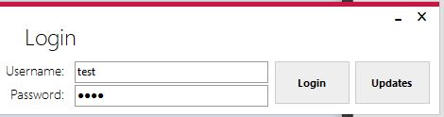

2. to add a password go to the add entry tab and enter some **FAKE** test details (this account is not private and any real details cannot be protected) 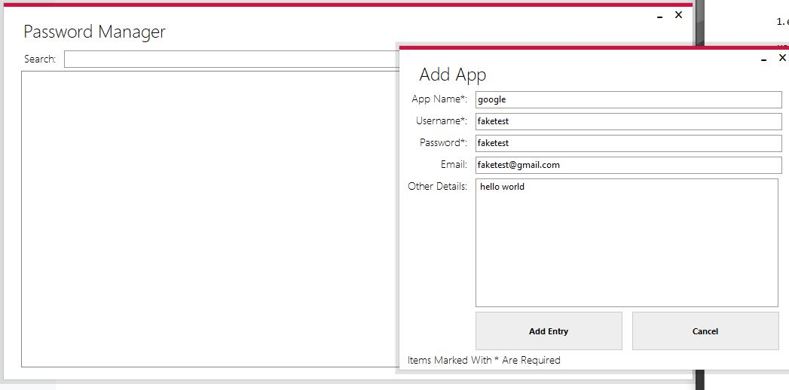

3. click refresh or search for your item.

